Summer Engineering Camp–June 20-26
9:00AM – 3:00PM
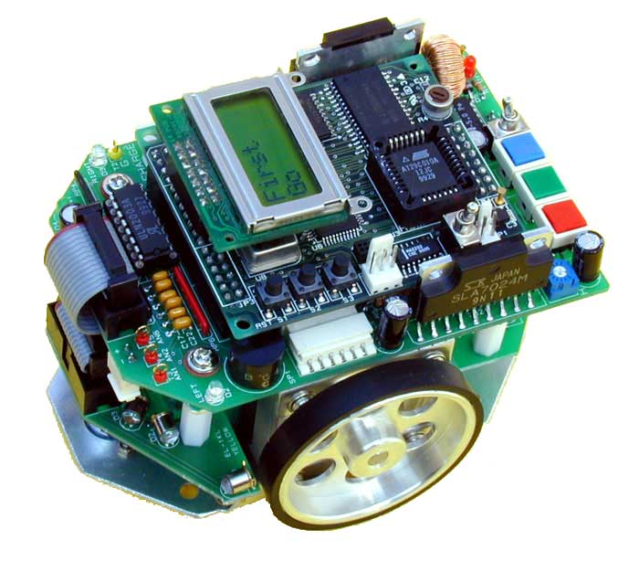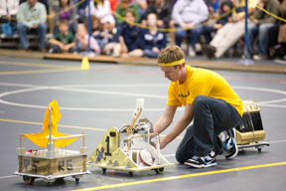
Early Bird Registration: $25.00 per person (ends May 15th)
Regular Registration $35.00 per person (due by June 6th)
4800 Regent Blvd. Irving, TX 75063
Send Registration Form via email to: slohr@devry.edu and call (972) 929-9743 for payment by phone

