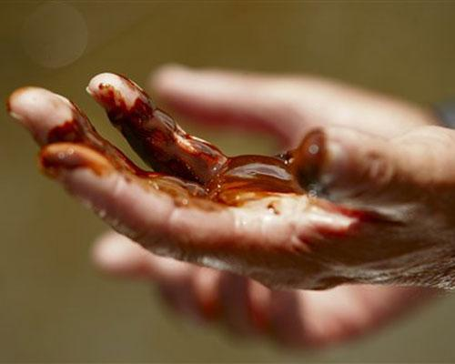

The planet in our hands…

Motto: Let us fix what we have broken…
The Environmental Science/Volunteering Club
- Founders: Diego Munoz (12), Murali Subramanian (11)

- Sponsor: Mr. David McLoda (Environmental Science, Pre-AP Biology, and PSAT Prep teacher at SEM)

- Meeting Times: Thursday after school (4:15-5:15 pm).

- Venue: Room 226

- Purpose: Applying our knowledge of science in order to help our environment.

- What we will be doing: We intend to volunteer at organizations in the Dallas area. We have two locations we will be volunteering at: Texas Discovery Gardens and the White Rock Lake.

- Refreshments will be served…

- You will gain community service hours through this club!!! Don’t MISS IT!!!

