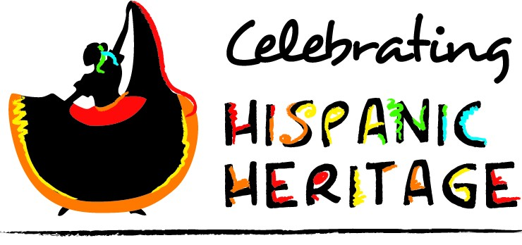



Guest Speaker: Evelio Flores, Founder of Group Mitotiliztli Yaoyollohtli Aztec Dance Performers

Special Performances: Mexihca Aztec Dancers, Ballet Folklorico Mestizo Townview, Instrumental, Singing, Break Dancing

Sponsored by

**Townview LULAC 1118**

When: Friday, October 11, 2013

Time: 2:45 - 4:15 P.M (8thPeriod)

Where: Townview Theatre

**“Preserving Our Indigenous Heritage”**