Volunteer Opportunities
with
Communities In Schools
at
Hector Garcia Middle School

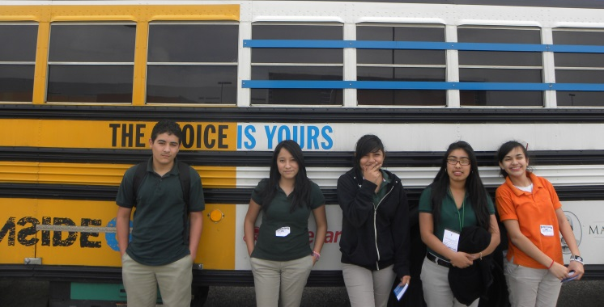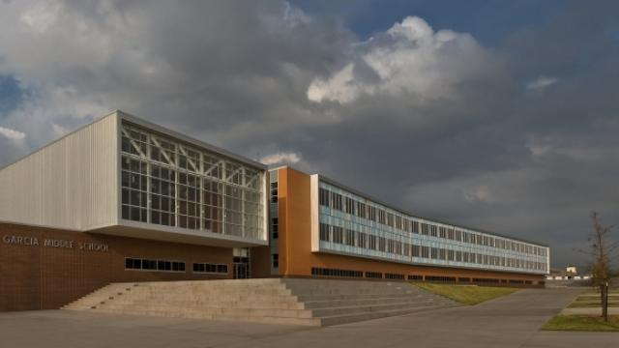
Five of 1,000 Hector Garcia students
Our campus, located ½ mile from Townview

- Mentor an at-risk student
  - Classwork help
  - Art
  - Sports
  - Games

- Afterschool homework club
  - Tutoring
  - Reading
  - Multiplication facts
  - Snacks & games

----------------------------------------------------------------

How to get involved…

- Complete the Volunteer Application/Consent for Background Check. Contact Ms. Pennington at pennington.cisdr@gmail.com or 972-502-5500 for an application or if you have any questions.
- Turn in your application, and bring your Drivers License or ID and Social Security card to Ms. Pennington at Hector Garcia Middle School.

Cara Pennington, MSW
Communities In Schools of the Dallas Region, Inc.
Campus Manager – Hector Garcia Middle School
700 East 8th Street, Dallas, TX 75203
(972) 502-5500
pennington.cisdr@gmail.com

