Health Professions Recruitment and Exposure Program 2017

HPREP

Attention Dallas Area High School Students (10th, 11th and 12th Grade)

Want to know about Medical School? • How to become a Doctor? •
Interested in a Health Profession Careers? • Want to be a nurse or physical therapist or dentist? • Want to be a scientist and make discoveries? • Learn what you can start doing NOW to become a successful applicant for college and medical school!

Come learn about internship, volunteer, and scholarship opportunities!

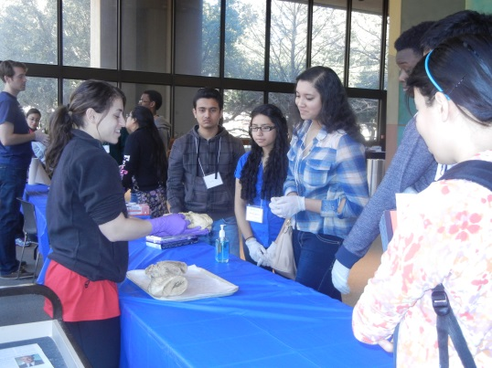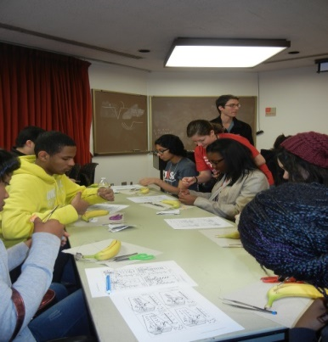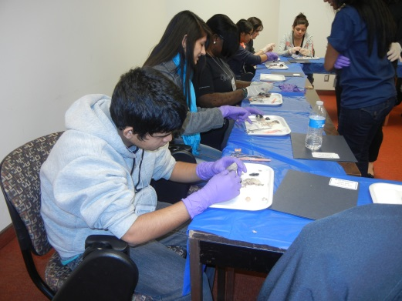
WHAT? HPREP is a FREE 5-week program with interactive workshops, a college/career fair, and information about college applications and financial aid

WHERE? UT Southwestern Medical School
5323 Harry Hines Blvd, Dallas, TX
Bus service will be available from designated DISD schools

WHEN? Saturday mornings from 8:00 A.M. to 12:00 P.M.
Jan. 7, 14, 21st, 28, and Feb. 4, 2017

HOW? To find application on the web: Google “HPREP UTSW Program” or
Check out the application at: https://ais.swmed.edu/redcap/surveys/?s=Y3W7P3RXKY
The application deadline is November 18, 2016. Acceptance based on well-written essays.

If you have any questions, please email hprep@utsouthwestern.edu

